**Retrieve Student Data from a Text File with the Option of Sorting and Searching.**

**GitHub Link: :** <https://github.com/pravallikaadineni/mainprojects.git>

**Step 1:** Creating a Simple text file externally using Notepad pre-populated with the Student data and named it as “search.txt”.

**Step 2**: Creating a Windows Console project in Visual Studio to display student data.

● Open Visual Studio.

● From the top menu select File->New->Project.

● In Create A New Project Screen, select Console app (.NET Core) from the list of available project types and click on Next.

● Enter Project Name project 1.6 as and click on Create.

**Step 3:**

Select the program.cs file on current tab and enter the code for searching and sorting the data

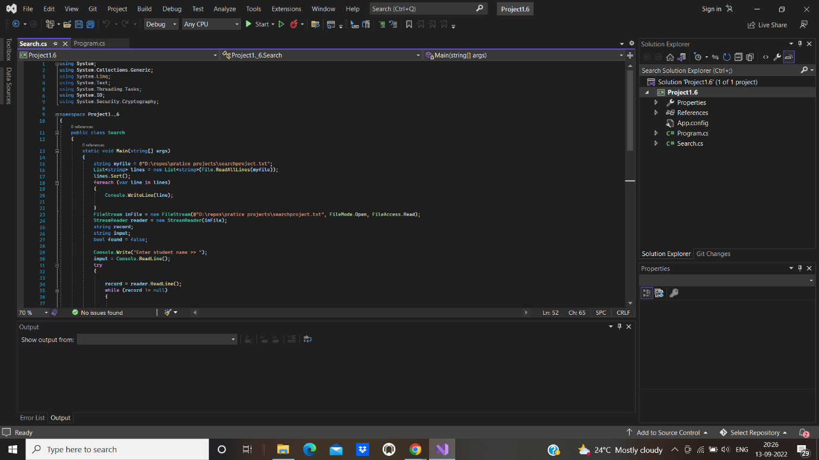

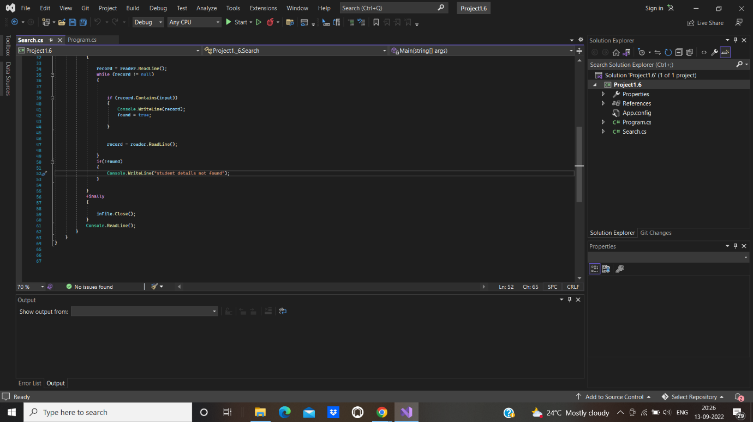

**Step 4:** Building the project

● From the top menu choose Build->Build Solution.

● If any compile errors are shown, fix them as required.

**Step 5:** Publishing and running the project

● From the top menu select Debug->Start Without Debugging.

● This will execute the program in a console window.

**Step 6:** Pushing the code to your GitHub repositories

Open your command prompt and navigate to the folder where you have created your files.

**cd <folder path>**

Initialize your repository using the following command:

**git init**

Add all the files to your git repository using the following command:

**git add .**

Commit the changes using the following command:

**git commit -m “upload”**

Push the files to the folder you created initially using the following command:

**git push -u origin main**